MINISTRY OF SCIENCE AND EDUCATION NATIONAL TECHNICAL UNIVERSITY “KHARKIV POLYTECHNIC INSTITUTE”

DEPARTMENT OF SOFTWARE ENGINEERING AND MANAGEMENT INFORMATION TECHNOLOGIES

Report from lab#4

Discipline “Software Architecture ”

Executed by: Student of group 1.КН201.8ei1

CHUKWU IRELE AMORIN

Checked by:

Prof. Khtasko

Task : collaboration diagram

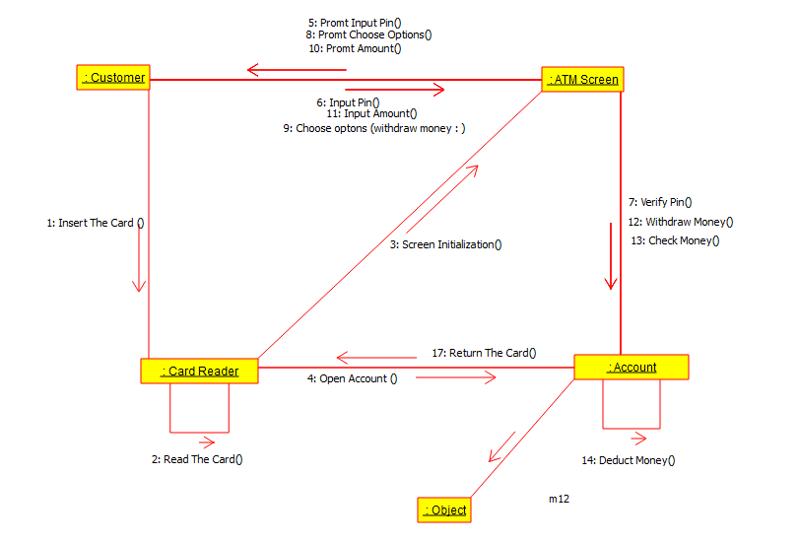

Collaboration Diagram: Atm System

This Atm System is a system that allows a customer to withdraw money from his/her **Account** using an account card via an Atm stand. The System verifies the card when the customer inserts the card to make sure it is not a malicious attempt to withdraw money. The system then ask for the amount to withdraw, the checks for the money in the account of the customer. If the money is available, the system then deduct the money from the account and gives it to the user .Then the system returns the card to the user.

This is a collaboration diagram, which shows the flow of **Operations** between various **Objects** in the **Atm System**